**Traditional development Model**

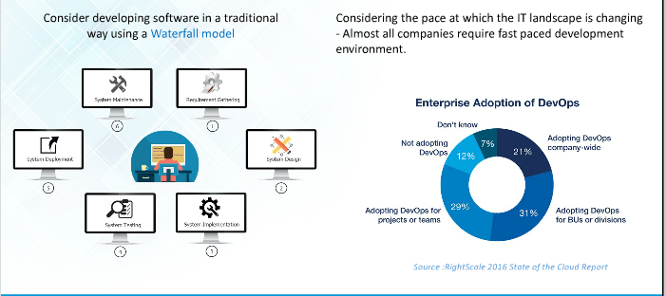

**Water fall Model Challenges**

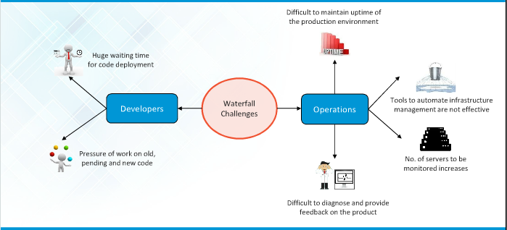

**What needs to be done**

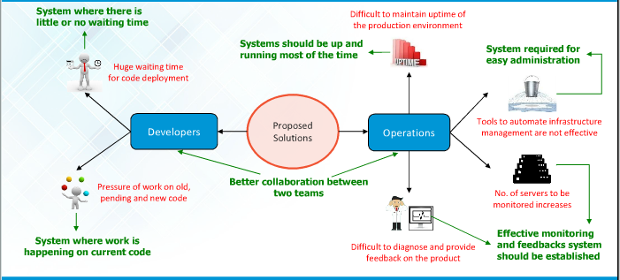

**SDLC Process Overview**

SDLC, Software Development Life Cycle is a process used by software industry to design, develop and test high quality software’s. The SDLC aims to produce high quality software that meets or exceeds customer expectations, reaches completion within times and cost estimates

* SDLC is the acronym of Software Development Life Cycle.
* It is also called as Software development process.
* The software development life cycle (SDLC) is a framework defining tasks performed at each step in the software development process.
* ISO/IEC 12207 is an international standard for software life-cycle processes. It aims to be the standard that defines all the tasks required for developing and

**SDLC Models**

A typical Software Development life cycle consists of the following stages:

Stage 1: Planning and Requirement Analysis

Stage 2: Defining Requirements

Stage 3: Designing the product architecture

Stage 4: Building or Developing the Product

Stage 5: Testing the Product

Stage 6: Deployment in the Market and Maintenance

**SDLC Models**

There are various software development life cycle models defined and designed which are followed during software development process. These models are also referred as "Software Development Process Models". Each process model follows a Series of steps unique to its type, in order to ensure success in process of software development.

Following are the most important and popular SDLC models followed in the induct

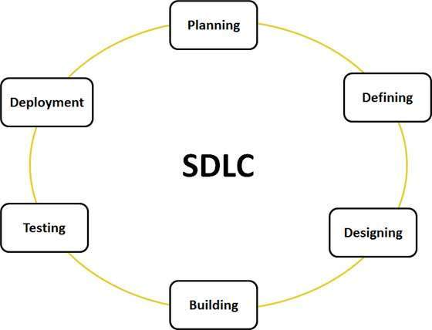

**SDLC Models**

* Waterfall Model
* Iterative Model
* Spiral Model
* V-Model
* Big Bang Model
* Agile Model

The other related methodologies are Agile Model, RAD Model, Rapid Application Development and Prototyping Models

**Traditional Waterfall Model**

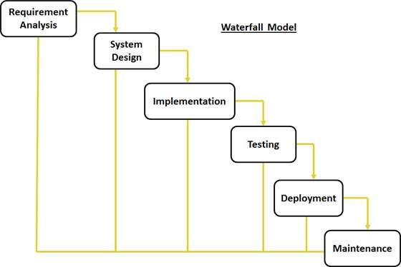

**Traditional Waterfall Models**

* Requirement Gathering and analysis
* System Design
* Implementation
* Integration and Testing
* Deployment of system
* Maintenance

**Waterfall Model Application :**

Every software developed is different and requires a suitable SDLC approach to be followed based on the internal and external factors. Some situations where the use of Waterfall model is most appropriate are:

* Requirements are very well documented, clear and fixed.
* Product definition is stable.
* Technology is understood and is not dynamic.
* There are no ambiguous requirements.
* Ample resources with required expertise are available to support the product.
* The project is short.

**Traditional Waterfall Models**

* Requirement Gathering and analysis
* System Design
* Implementation
* Integration and Testing
* Deployment of system
* Maintenance

**Waterfall Model Application :**

Every software developed is different and requires a suitable SDLC approach to be followed based on the internal and external factors. Some situations where the use of Waterfall model is most appropriate are:

* Requirements are very well documented, clear and fixed.
* Product definition is stable.
* Technology is understood and is not dynamic.
* There are no ambiguous requirements.
* Ample resources with required expertise are available to support the product.
* The project is short.

**What is Agile?**

Agile model believes that every project needs to be handled differently and the existing methods need to be tailored to best suit the project requirements. In agile the tasks are divided to time boxes (small time frames) to deliver specific features for a release.

Iterative approach is taken and working software build is delivered after each iteration. Each build is incremental in terms of features; the final build holds all the features required by the customer.

**Here is a graphical illustration of the Agile Model**

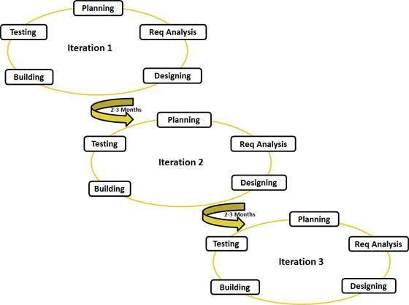

**Agile Overview**

* Requirement Gathering and analysis
* System Design
* Implementation
* Integration and Testing
* Deployment of system
* Maintenance

**Waterfall Model Application:**

Every software developed is different and requires a suitable SDLC approach to be followed based on the internal and external factors. Some situations where the use of Waterfall model is most appropriate are:

* Requirements are very well documented, clear and fixed.
* Product definition is stable.
* Technology is understood and is not dynamic.
* There are no ambiguous requirements.
* Ample resources with required expertise are available to support the product.
* The project is short.

**Agile Overview**

* Requirement Gathering and analysis
* System Design
* Implementation
* Integration and Testing
* Deployment of system
* Maintenance

**Waterfall Model Application:**

Every software developed is different and requires a suitable SDLC approach to be followed based on the internal and external factors. Some situations where the use of Waterfall model is most appropriate are:

* Requirements are very well documented, clear and fixed.
* Product definition is stable.
* Technology is understood and is not dynamic.
* There are no ambiguous requirements.
* Ample resources with required expertise are available to support the product.
* The project is short.